Overview:
The purpose of this report is to draw insights for the vendor using transactional data on from 3900 purchases across various item categories. The goal is to reveal insights about the consumer spending patterns, product preferences, subscription behaviour, and more, to guide business decisions to help the business grow.
Summary of Dataset:
- Rows: 3900
- Columns: 18
- Key features:
  - Information on customer demographics (Age, gender, location, subscription status)
  - Purchase details (Item purchased, Category, purchase amount, season, size, color)
  - Shopping behaviour (Discounts applied, promo used, precious purchases, frequency of purchases, review rating, shipping type).
  - Missing data: 37 values in the review rating column.
Exploratory Data Analysis using Python (pandas):
- Data was loaded via pandas.
- Initial exploration: Done by df.info() to check structure and df.describe() for summary statistics.
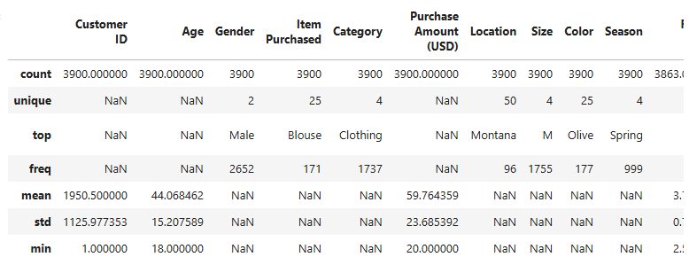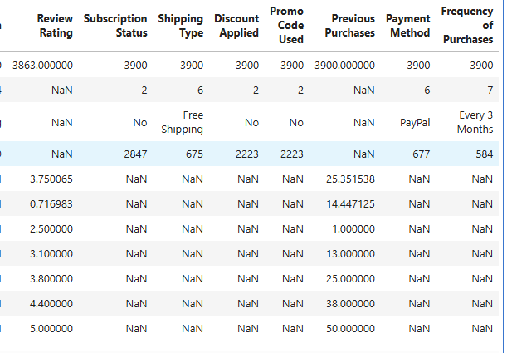
- Missing data: This was seen in the review ratings columns via df.isnull().sum() and was filled using median values based on the category the product came from
  - The median was used, as opposed to mean, because outlier cases would impart skew to the rating for null values.
    - The median is a good choice because it gives the middle value, offering consistency in data.
  - df[‘Review Rating’] = df.groupby(‘Category’)[‘Review Rating’].transform(lambda x: x.fillna(x.median()))
Before: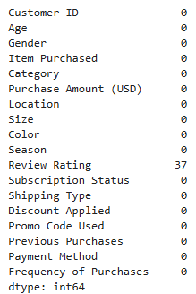After: 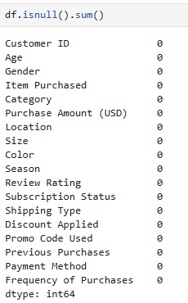
- Column standardization: columns were renamed using snake case to enhance readability and documentation.
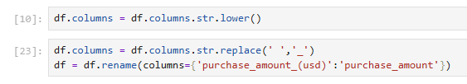
- Future Engineering:
  - Created age group by stratifying age data into quadrants and generating labels per quadrant group of customers.
  - Created purchase frequency days columns which were stratified via Frequency of purchases data
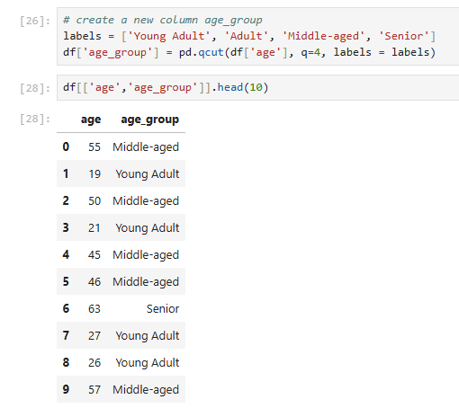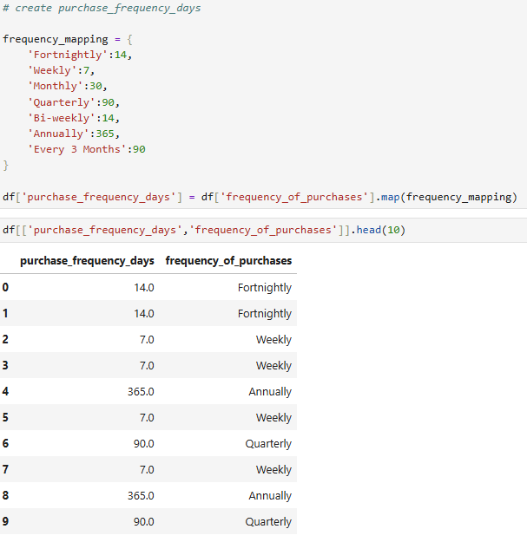

- Checked for data consistency: Checked discount_applied and promo_code_used for redundancy. Promo_code_used was dropped.
Data analysis via SQL:
Performed structured analysis in PostgreSQL to answer typical business questions:
- Revenue by gender – Compared total revenue between genders
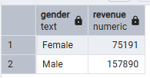
- High-spend via discount – Identified customers who used discounts but spent more than the average amount.
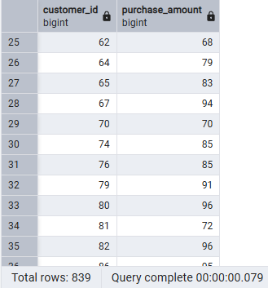
- Top 5 Products by rating – Found the top 5 products with the highest average reviews.
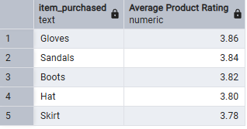
- Comparison of purchase amounts between standard and express shipping
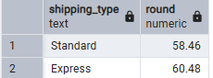
- Who spends more between subscribers and non-subscribers
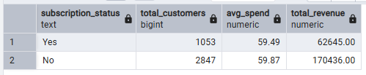
- Which of the top 5 products have the highest percentage of purchases when a discount is applied
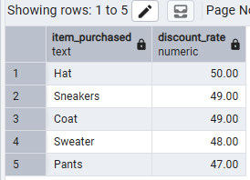
- Customers purchase history based on their loyalty (segmented based on their previous purchases
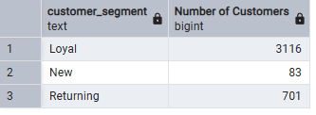
- Top 3 most purchased products within each category
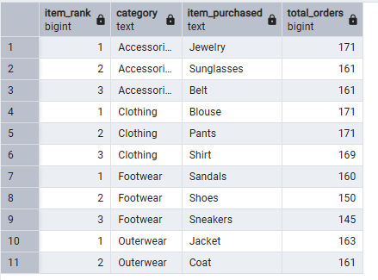
- Do repeat buyers (more than 5 purchases) likely to subscribe?
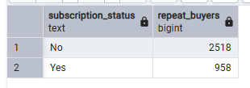
- What is the revenue contribution by age group?
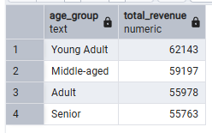
Dashboard in Power BI:
Used the data in Power BI to present information visually for stakeholders.
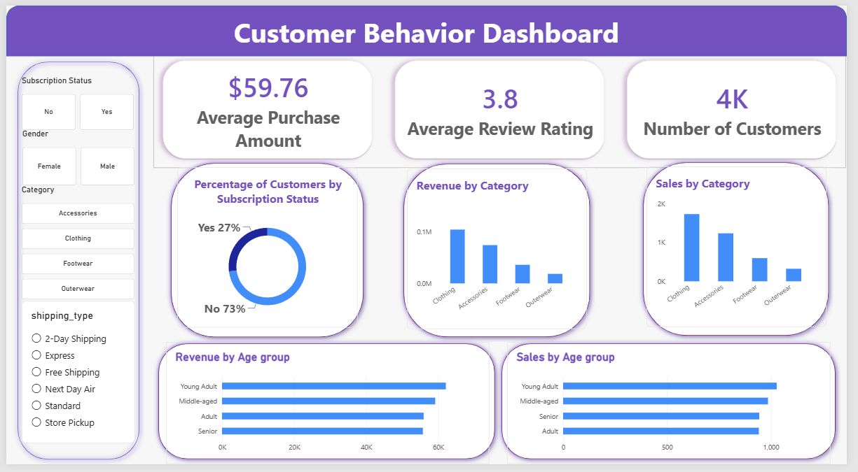
Business recommendations:
- Customer Loyalty Program - Use incentives to bring in repeat buyers into the “Loyal” category.
- Enhance subscription services – Promote benefits for subscribers to increase the subscriber count.
- Product positioning – Use the data to highlight the best-selling products
- Targeted marketing – Focusing efforts on high-revenue age groups and express shipping folks.
- Review discount policy – Balance sales boosts with margin control.

